Our Lady of
Mount Carmel

*

Church Ministries

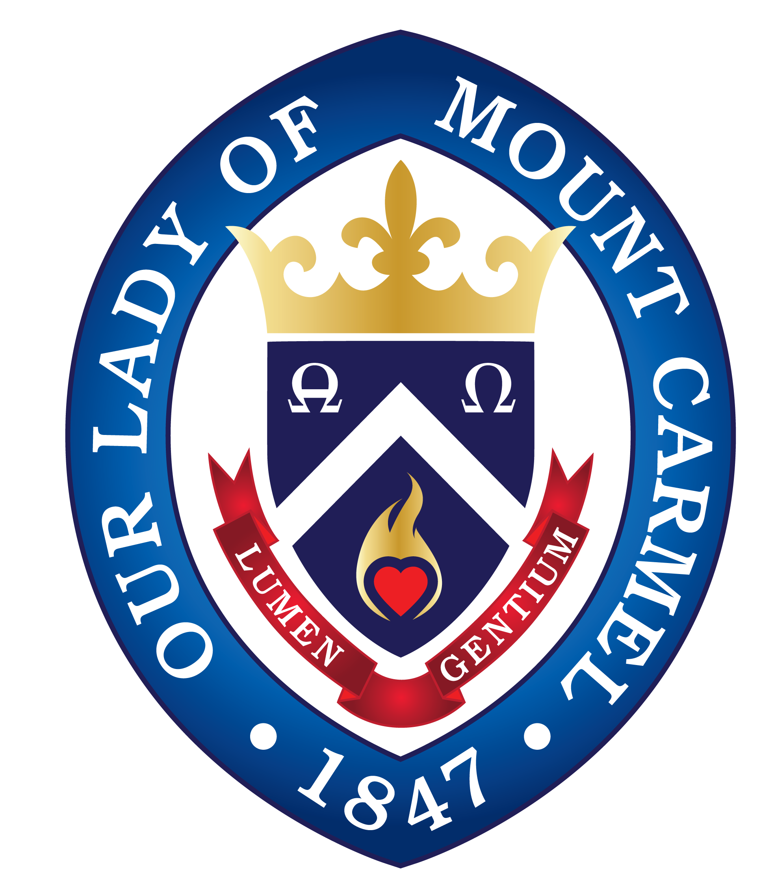

Handymen
Ministry leader requested.
Please contact the rectory at 973-334-1017

Time Commitment: As much or as little as you can spare.

A team of handymen is desired to help with projects in and around the rectory and Church. For example, in the rectory: the stairway to the basement needs new handrails, treads, lighting and painting; hallway molding needs to be replaced; a ceiling in one of the rooms needs to be taped / spackled / painted. In the Church, the Hinds Room needs a makeover. There are some bigger jobs but we can talk about those later :) This could also be an opportunity to show your sons / daughters how to do this work. Thank you for your help!

-------------------------------------------------------------------------------
OLMC Ornaments
Please contact the rectory at 973-334-1017

Time Commitment: Time before Advent to assist with inventory and ordering, then during Advent to assist with sales.

Almost every year, a new OLMC ornament is available for purchase. The ornament is created by an outside vendor but we have to select the ornament, order it, receive it and sell it. It is a beautiful image of one of the church’s stained glass windows and makes for a wonderful gift.

Rectory office help
Please contact the Rectory.
973-334-1017

Time Commitment: As much or as little as you can spare.

Throughout the year, the rectory office has the need for help in all kinds of activities including organizing, mailings, stuffing the bulletin and Bishop’s Annual Appeal rollout. When some help is needed, you would be notified.
Of special note are requests for the following:
- Photo editors: this person would take images for publication and crop them, turn them to black-and-white, make minor edits. The Microsoft product Paint is used. Christina will train you as to how to use it.
- Graphic designers: Almost all of the posters and flyers for church events are done in-house using free Windows-based software: paint.net. Help is needed to create these and to maintain the OLMC brand and theming. If you would like to learn how to use paint.net, Christina will train you.
--------------------------------------------------------------------------------
Thrift Shop
Betty Bandura
973-402-8884

Time Commitment: One (1) hour per week or more

The OLMC Thrift Shop has available clothes and housewares for sale at nominal prices. The members of this ministry work at the shop selling items but also maintain inventory and organize the store.

Nazareth Farm - mission trip for teens (with chaperones)
Ministry leader requested.
Please contact the rectory at 973-334-1017

Time commitment: Time before the trip to organize. One week away in West Virginia.

In the summer, a teen mission trip to Nazareth Farm is planned. Here, the teens not only serve the nearby residents with home repair but they participate in a retreat. Father Daniel attended when he was younger and calls it “transformational.” We are looking for one or more individuals to coordinate the trip and for 2-3 individuals to attend.

--------------------------------------------------------------------------------
Holy Water/ Baptismal Fonts
Ministry leader requested.
Please contact the rectory at 973-334-1017

Time commitment: A few minutes each weekend

Members of this ministry will fill-up the holy water and baptismal fonts throughout the church, as needed. In addition, they ensure that the main holy water font (in the foyer at the end of the entrance ramp) is filled.

OLMC History
Christina Simonetti
973-334-1017

Time Commitment: A couple of one-time gatherings. Then, if you have the desire, finding old photos, albums, and yearbooks to find photos and historical information.

Gatherings will be held with the purpose of collecting anecdotes, historical facts, and photos of Our Lady of Mount Carmel and all of its facilities: the Church, school, convent, rectory, cemeteries (we have two!), Shrine of St. Therese, … All will be compiled and maintained as an OLMC historical archive.

--------------------------------------------------------------------------------
Church Décor / Altar vases / Christmas & Easter Flowers
Ministry leader requested.
Please contact the rectory at 973-334-1017

Time commitment:
- Altar vases (weekly): water as needed, 15 minutes to remove from the sanctuary, rinse, drop off at a florist.
- Christmas and Easter seasons: 2 hours to set up, 20 minutes to water as needed, removed faded plants and replace as necessary, 2 hours to remove/clean-up.
In this ministry, we decorate and beautify the sanctuary and other areas of the church with plants and wreaths in preparation for Christmas and Easter seasons. Detailed instructions and photos are available, if needed, and no experience is necessary to participate in this wonderful ministry. Also, fresh bouquets from the florist are placed in the sanctuary each week.

Adoration
Marie Christelle Burke
mariechristelle0822@gmail.com

Time Commitment: One hour Wednesdays 6:45-8:30pm or Fridays 8:30am-2:15pm

Please join us for an hour of Adoration and spend time with our Lord and let Him repose within your heart..... come gaze upon Him, contemplate Him to deepen your friendship with Jesus and offer it for peace in the world, for the suffering souls on Earth & Purgatory and for the Holy Mother Church. Don’t let our Lord repose early because we have no adorers to keep Jesus company for the time slot. For Friday Adoration, please sign up in the Adoration book.

--------------------------------------------------------------------------------
Baptisms
Ronnie Sabloff
Please contact the rectory at 973-334-1017

Time Commitment: A few minutes before and after a Baptism which is usually held on Sunday but can occur during a Mass.

In this ministry, we help setup and take down all that is needed for a Baptism. When a Baptism occurs during Mass, a few more additional activities are involved, such as reserving front pews for the family.

Wedding Ministry
Lori Testa
ltesta@olmcboonton.org

Time Commitment: schedule differs

In the Wedding Ministry we are called to help with meeting new couples to get them started in the preparation process, help with meeting couples and their mentors to get them started on Witness to Love, attend wedding rehearsals, and in the future, attend training/prep courses at OLMC and host marriage centered events.

Please see the letter from Lori Testa for more information.

--------------------------------------------------------------------------------Funeral Ministry
Bonny O’Mullane
973-610-0504

Time Commitment: 2 – 6 hours per month

The goal of the OLMC funeral team is to provide love and comfort to the bereaved. Our team of caring volunteers, meets with bereaved families to help them plan the funeral and creates a beautiful program for their loved one’s Mass. We provide adult altar servers for the Mass and look after the family during the service.

Bereavement
Grace Ryerson
973-335-1926

Time Commitment: Varies depending on your schedule

This new and evolving ministry will help the bereaved in planning the funeral Mass. We are in the process of developing an individualized funeral Mass program for those whose funeral will be at Our Lady of Mount Carmel Church. In addition, we will extend our support to the family/loved ones by way of scheduled follow-up contacts and a six-week support group (scheduled to begin in the Fall). No experience is necessary, and those who wish to participate will buddy up with a partner who is well-versed in the process. Thank you!

--------------------------------------------------------------------------------
Caring Ministry
Judy Mondino
973-479-5397 * fjm78@aol.om

Time Commitment: At your convenience.

The Caring Ministry sends cards to parishioners who are ill, homebound, in a time of need, etc. Cards are created (art!) and we are looking for individuals to fill in the inside (you will be given samples.) Supplies are provided and cards are picked up when you are finished. We hope those who love to write or are homebound will be interested.

Altar Servers
Father Daniel O’Mullane
Please contact the rectory at 973-334-1017

Altar servers assist the priest during Mass and participate in various services and celebrations including the Triduum and the procession during the Feast of Our Lady of Mount Carmel.

--------------------------------------------------------------------------------
Lectors
Rita Foegen
973-615-3104

Time Commitment: One weekend per month or more

Our mission is to proclaim the Word at the Liturgical Celebration one usually attends, to personally reflect on the Word prior to proclaiming it, and to attend scheduled Lector meetings about three times per year. You are provided with a workbook and other aids to assist in preparation.

--------------------------------------------------------------------------------
Extraordinary Ministers of Holy Communion (EMHC)
Anita Patterson
Please contact the rectory at 973-334-1017

Time Commitment: Serve during Mass. Meetings 3-4 evenings per year.

EMHCs are members of the lay faithful who are called upon and commissioned to assist in the distribution of Holy Communion either within the Eucharistic celebration or at another occasion such as a Communion Service or home visit.
Ushers
Ron Milano
973-335-3261

Time Commitment: A few minutes during the weekend Masses

The primary responsibility of the ushers is to take up the offertory collection after the Liturgy of the Word. A few times per year, during crowded Masses, ushers are asked to find empty seats and direct standing people to find those seats.
Both regular and spur-of-the-moment volunteers are welcome. Regular ushers will be at almost every Mass, and if you can help, let the lead usher know at that Mass - or step up if it looks like there are insufficient ushers. This is a low-level commitment that truly helps the parish. Thank you!

--------------------------------------------------------------------------------
Religious Education (CCD) & Family Faith Formation
Faith Rose
Please contact the rectory at 973-334-1017

Time Commitment: Varies

The education of our youth in the Beauty, Goodness and Truth of God is of utmost importance. Not only do catechists teach our children and grandchildren, but also members of this ministry help as needed in preparing materials, setting up the classroom, maintaining records and more.

RCIA: Rite of Christian Initiation of Adults
Ministry leader requested.
Please contact the rectory at 973-334-1017

Time Commitment: Monthly involvement from September to the Easter Vigil.

Each year on Holy Saturday during the Easter Vigil, thousands are baptized into the Catholic Church in the United States. Parishes welcome these new Catholics through the RCIA. Candidates are gradually introduced to aspects of Catholic beliefs and practices over a period of months. The RCIA team helps the candidates as they search and discern.

--------------------------------------------------------------------------------
Financial Peace University
Chris Ramsden
Please contact the rectory at 973-334-1017

Time Commitment: Attendees are in class 1.5 hours per week for 9 weeks. Leaders spend some more time preparing.

At Financial Peace University, you’ll learn how to save for an emergency fund, get out of debt, save for retirement and college, pay off the house, build wealth, and give generously. It’s a lot to work, but it’s all incredibly motivating—and rewarding! Don’t worry, Dave Ramsey simplifies the process by taking you through the 7 Baby Steps. You can sign up to take the class or learn how to become a leader.

Bible Study
Ministry leader requested.
Please contact the rectory at 973-334-1017

Time Commitment: Approximately 1 ½ hours per week in class with video and discussion when study is in session, along with workbook reading and writing outside of class.
Option for online participation.
Day and time to be determined.
Each Bible study session is comprised of approximately 10 lessons which draw upon Scripture passages. Inspiring and enlightening topics are covered in videos and accompanying study materials. Past sessions have included The Mass by Bishop Robert Barron, Wisdom: God's Vision for Life, and Psalms: The School of Prayer.
Material requirements: An affordable workbook for each session; possible nominal share in class video or streaming lessons.
--------------------------------------------------------------------------------
Spiritual Mentoring
Bonny O’Mullane
973- 610-0504

Time Commitment: One 45min-1hour meeting per month

For those who are feeling prompted to grow in our Catholic Faith, our team of Spiritual Mentors provides accompaniment and one-on-one support.

Choir
Carl Bolleia
cbolleia@olmcboonton.org

Time Commitment: Thursday nights for rehearsal and Sunday mornings for 11:15 Mass.

Perhaps you’ve thought about singing in the choir… or perhaps you haven’t! Well, OLMC would love to welcome you to sing. Our choir is a warm group of friends that loves to sing and laugh together. Our goal is to present beautiful sacred music, chant, anthems, Masses, requiems, and cantatas by the greatest composers of Western music. However, we need YOU to do that. Please consider joining to build up our choral program and to continue to facilitate the making of sacred music here at OLMC. Maybe you’d like to commit seasonally? For Advent and Christmas? Anyone is welcome. Please let me know - I’d love to talk with you! - Dr. Carl Bolleia

-------------------------------------------------------------------------------Busy Hands
Peg Bufano
Please contact the rectory at 973-334-1017

Time Commitment: Mondays 1:00-2:30pm

In this ministry, we help knit and crochet items such as hats and mittens for babies and blankets and afghans for the Lakota Sioux Indian Reservations through St. Paul’s Indian Mission in Marty, South Dakota. Additionally, we make prayer shawls and lap blankets for the homebound.

Catholic Daughters of America, Court Joan of Arc #425
Theresa Whritenour
Please contact the rectory at 973-334-1017

Time Commitment: One meeting per month

The Catholic Daughters of the Americas is one of the oldest and largest organizations of Catholic women in the Americas. They donate to charities, administer scholarship programs and strive “to be helping hands where there is pain, poverty, sorrow or sickness.” The CDA Court Joan of Arc recently celebrated its 100th Anniversary and provides many services to OLMC. Become a member of “People helping People.”

Please see the detailed information sheet about the CDA Court Joan of Arc #425.

--------------------------------------------------------------------------------
Knights of Columbus
Bob Marcello
973-287-9076

Time Commitment: One meeting per month

The Knights of Columbus “are Catholic men building a bridge back to faith. There is much good and necessary work to be done in this world, and that's what Knights do every day.” The Knights of Columbus here in Boonton recently celebrated its 100th Anniversary and provides many services to OLMC.

Spanish Mass & Evangelizacion /
Spanish Outreach
Rolly & Catalina Galloza
201-919-4779

Time Commitment: Varies

Those who can speak Spanish assist with reaching out to our Hispanic community members. We assist them in their faith journey and encourage them to attend various events such as the Saturday 7:00pm Spanish Mass and the Feast of Our Lady of Guadalupe.

--------------------------------------------------------------------------------
English as a Second Language /
ESL
Margaret Mainardi
Please contact the rectory at 973-334-1017

Time Commitment: 1.5 hours per week. The only requirement is that you speak English.

We are looking for English-speaking volunteers who can bake treats, help students during class, teach the advanced classes, and people who can help with transportation to and from classes on Mondays at 7:00pm and 8:30pm.

Social Outreach: Giving Tree and Food Pantry
Lucille Rockis
973-335-4981

Time Commitment: Varies

OLMC participates in the Boonton food pantry and the Christmas Giving Tree by providing requested items. Each week, these items are brought by volunteers to the pantry location on Washington Street. Every Christmas, Giving Tree gifts are sorted, packaged and distributed to families.

--------------------------------------------------------------------------------
Victoria Mews / Fireman's Home / Home Visits
Please contact the rectory at 973-334-1017

Time Commitment: at least 20 minutes per week or more if you desire. For Victoria Mews, 15-30 minutes per week of preparation and 30 minutes at the facility.

Many of our parishioners cannot attend OLMC Church on a regular basis. Therefore, the members of this ministry will bring the Blessed Sacrament to them at their residence. In addition, the Victoria Mews ministry members lead a half hour prayer service on an assigned Sunday and distribute the Holy Eucharist; two members go each week.

Church and Gordon Hall Cleaning
Ministry leader requested.
Please contact the rectory at 973-334-1017

Time Commitment: Thursdays, 9-10am

This ministry gives honor and glory to God by ensuring His house is clean, organized, and welcoming. Each week, the floors throughout the church and hall are swept, carpets vacuumed, rooms cleaned, hall tables cleaned, and occasionally dusted. Serving on this ministry is an opportunity for fellowship with others and with the Lord as well.
--------------------------------------------------------------------------------
Cemetery
Christina Simonetti
973-334-1017

Time Commitment: As much or as little as you can spare.

Here, you can assist the office staff with maintaining cemetery records. In addition to keeping an eye on the landscaping needs of the cemetery, the record-keeping could use some enhancements. For example, the pages of the cemetery books (there are seven LARGE books) are so old that they are disintegrating. These pages need to be photocopied and put into new binders. In addition, photos of each plot and grave are to be taken and added to the binder documentation, and at some point, all of this information may go up on a website to help those seeking ancestry information.

Childcare/Babysitting
Bonny O’Mullane
973-610-0504

Time Commitment: Varies

Occasionally, babysitting is desired at an OLMC event such as Financial Peace University or parenting groups. Members of this ministry volunteer to look after the children so that their parents may fully engage in the sessions.

--------------------------------------------------------------------------------
Cooking
Bonny O’Mullane
bonnyomullane@gmail.com –or- (973) 610-0504

Time Commitment: Shop for groceries, cook and deliver meals

Join our team of chefs who sign up online to ensure our pastor has a home cooked meal once a week. Volunteering to provide a meal once a month or once a year will be much appreciated. Email Bonny to sign up and receive details about dietary preferences and delivery times.

Hospitality and Events
Please contact the Rectory.
973-334-1017

Time Commitment: As much or as little as you can spare. When help is needed, a request will be made.

OLMC has numerous events and feasts throughout the year. For example, there is Lessons and Carols in December and the Feast of Our Lady of Mount Carmel in July. In addition, there is a new gathering that is happening a couple of times per month after the 11:15am Mass, and the hope is that it will expand to the other Masses. For those of you who like parties :-), we would ask for your help in any number of ways - you pick which you would like to participate in. These include:
- Baking / Cooking
- Creating publicity such as flyers
- Purchasing supplies, paper plates …
- Setting up the reception area
- Setting up the Church
- More…
As mentioned above, our events include: Lessons and Carols, the Feast of Our Lady of Mount Carmel, the Annual Golf Classic and Parish Dinner, Soup Supper during Lent, after-Mass gatherings, special Masses, movie night, seminars, retreats, etc.

---------------------------------------------------------------------------
Are you looking for something and don’t see it?

If you are interested in a ministry and don’t see it - or - if you have a suggestion for a new one, please contact the rectory and let us know. We’d love to hear from you!

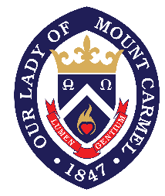

Our Lady of Mount Carmel
910 Birch Street
Boonton, NJ 07005
(973) 334-1017
olmc.church

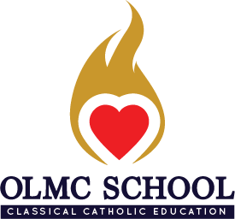

OLMC School
205 Oak Street
Boonton, NJ 07005
(973) 334-2777
olmc.academy

